**Report on**

**Instationary Gas Flows:**

**Complexity and Algorithms**

By,

HIMANSHU NAGPURE

Summer Research Intern, TU Berlin

Date of Submission: 11th July, 2017

When the value of flow in each stage is equal to one another, it is called Stationary gas flow. Otherwise, it is Instationary gas flow.

**Problem:**

Maximum k-stage gas s-t flow problem

Input: A network G with source s, sink t and feasible node potentials with range [π_min, π_max].

Objective: Find a feasible k-stage gas s-t flow of maximum value

**Approach:**

Initially, getting an intuition of how an optimal solution would look like is important. For this, let’s suppose we fixed the potentials of s and t to same value and have two nodes in between. The maximum feasible stationary gas flow for a single stage will be zero in this case. However, when the stages are increased more than two, we are able to get a positive value of flow as shown in the figure.

u

4

v

3

t

t

v

t

s

s

s

2

u

1

u

v

0

Π2

Π1

Π3

Generally, we deal with networks where potentials of source (s) and sink (t) are same. Hence, in most of our examples, we will assume them equal. A simple logic for a solution in 3 stage network lies in the fact that taking the flow positive two times and negative one time in such a way that 2*positive is greater than negative flow gives us a 3-stage instationary gas flow of positive net flow. We also have to take care of the fact that sum of flows in each edge of all stages should be equal, hence ensuring overall stationary gas flow in 3 stages. That means,

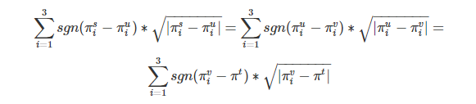

In this case, we get a flow of value 2*1-sqrt (2) = 0.586. However, this is just an intuitive solution. The result obtained from the computer when the same problem is fit comes out to be 0.60645. The actual maximum flow value is quite close to what we intuitively thought.

Here is the network flow diagram for the result:

4

3.45

3

2.67

2

1.33

1

0.55

0

Π2

Π1

Π3

We can play with the intuitive idea and come up with solutions for different stages and number of nodes. For example, if we take total of 6 nodes (with potential of s at 4, t at 0 and range of potentials from 0-4) and have 3 stages, we can have a stationary and an instationary solution. In stationary solution, we multiply the feasible stationary gas-flow solution for one stage 3 times to yield the value of flow equal to 0.57. Whereas in instationary solution, we can fix the potentials of source and sink and vary the rest potentials according to the intuitive solution for 4 nodes. In this way, we get a flow value equal to 0.586. However, this is not the maximum value possible. Fitting the problem to the same computational technique, we get the following network flow as the optimal solution for 6 nodes with the optimal flow value equal to 2.6833.

4

3.2

3.2

3.2

3

2.4

2.4

2.4

2

1.6

1.6

1.6

1

0.8

0.8

0.8

0

Π2

Π1

Π3

Now, maintaining the potentials of s and t to 2 and varying the potentials of other 4 nodes, we get a maximum flow of value 0.5744 which is lower than what we got for 4 nodes (equal to 0.60645). The network flow diagram for 6 nodes where potentials of s and t are fixed to 2 is shown below:

4

3.23

3.18

3

2.85

2.81

2

1.57

1.57

1

0.02

0.65

0.22

Π1

0

Π3

Π2

In general, the flow value keeps on decreasing as we increase the number of nodes keeping the stages constant and finally reaches zero for infinite nodes. The following table lists the flow values for various nodes (3 stage network with s and t potentials equal to 2):

|  |  |  |  |  |  |
| --- | --- | --- | --- | --- | --- |
| Nodes | 4 | 5 | 6 | 7 | 8 |
| Flow value | 0.60645 | 0.5878 | 0.5744 | 0.5429 | 0.5346 |

On the other hand, if we increase the stages in the network, we see exactly opposite scenario. Lets take an example of 4 nodes but with 5 stages keeping s and t potentials equal to 2. Based on intuition, one might think that we can use the solution of 3 stages and use approximately 2 times the flow values from 1st stage, 1 time from 2nd stage and 2 times from 3rd stage. It is however diffficult to arrive at a solution using this technique. Harnessing the power of computers lead us to the following network flow solution:

4

3.54

3

2.91

2

1.72

1.72

1.63

1.72

1

0

Π5

Π4

Π3

Π2

Π1

The maximum flow value comes out to be 0.7799 which is higher than what we got for 3 stage flow (0.60645). We can also generalise this result and come to a conclusion that increasing the stages increases the maximum value of flow. The following table lists the values of flow for various stages keeping the nodes constant (=4) and s and t potentials equal to 2:

|  |  |  |  |  |  |
| --- | --- | --- | --- | --- | --- |
| Stages | 3 | 4 | 5 | 6 | 7 |
| Flow value | 0.60645 | 0.6656 | 0.7799 | 1.2129 | 1.213 |

Therefore, increasing the nodes keeping the stages constant decreases the flow whereas increasing the stages keeping the nodes constant increases the flow value.

The above statement is valid for any combination of potentials of s and t within the specified range.

It is better to look at the values of maximum flow when the potential values of s and t varies.

The following tables contain flow values for different combinations of s and t potentials with a step size of 0.5 (with varying stages and keeping the nodes constant):

|  |  |  |  |  |  |  |  |  |  |  |
| --- | --- | --- | --- | --- | --- | --- | --- | --- | --- | --- |
|  |  |  | **3 Stage – 4 Nodes** | | | | |  |  |  |
|  | **πt** | **0** | **0.5** | **1** | **1.5** | **2** | **2.5** | **3** | **3.5** | **4** |
| **πs** |  |  |  |  |  |  |  |  |  |  |
| **0** |  | **0** | -0.556 | -0.7863 | -0.963 | -1.1623 | -1.369 | -1.573 | -1.8667 | -2 |
| **0.5** |  | 1.2247 | **0.3328** | 0.084 | -0.1138 | -0.2837 | -0.653 | -1.023 | -1.503 | -1.8667 |
| **1** |  | 1.73205 | 1.2247 | **0.5052** | 0.2817 | 0.1186 | -0.044 | -0.249 | -1.123 | -1.7136 |
| **1.5** |  | 2.1213 | 1.73205 | 1.2247 | **0.5868** | 0.3969 | 0.1955 | -0.044 | -0.0533 | -1.589 |
| **2** |  | 2.4495 | 2.1213 | 1.73205 | 1.2247 | **0.60645** | 0.3969 | 0.11863 | -0.4879 | -1.463 |
| **2.5** |  | 2.7386 | 2.4495 | 2.1213 | 1.73205 | 1.2247 | **0.5764** | 0.2817 | -0.365 | -1.123 |
| **3** |  | 3 | 2.7386 | 2.4495 | 2.1213 | 1.73205 | 1.2247 | **0.470625** | -0.001 | -0.8856 |
| **3.5** |  | 3.2404 | 3 | 2.7386 | 2.4495 | 2.1213 | 1.73205 | 1.2247 | **0.3328** | -0.556 |
| **4** |  | 3.4641 | 3.2404 | 3 | 2.7386 | 2.4495 | 2.1213 | 1.73205 | 1.2247 | **0** |
|  |  |  |  |  |  |  |  |  |  |  |
|  |  |  |  |  |  |  |  |  |  |  |
|  |  | **4 Stage – 4 Nodes** | | | | |  |  |  |  |
|  | **πt** | **0** | **0.5** | **1** | **1.5** | **2** | **2.5** | **3** | **3.5** | **4** |
| **πs** |  |  |  |  |  |  |  |  |  |  |
| **0** |  | **0** | -0.765 | -1.097 | -1.275 | -1.552 | -1.735 | -1.9 | -2.104 | -2.667 |
| **0.5** |  | 1.633 | **0.5334** | 0.2566 | 0.04025 | -0.211 | -0.9719 | -1.199 | -1.492 | -2.104 |
| **1** |  | 2.3094 | 1.633 | **0.5306** | 0.4611 | 0.0808 | -0.372 | -0.9099 | -1.2074 | -1.9003 |
| **1.5** |  | 2.8284 | 2.3094 | 1.633 | **0.744** | 0.3616 | -0.0824 | -0.3722 | -0.972 | -1.735 |
| **2** |  | 3.266 | 2.8284 | 2.3094 | 1.633 | **0.6656** | 0.23 | 0.0808 | -0.822 | -1.552 |
| **2.5** |  | 3.6515 | 3.266 | 2.8284 | 2.3094 | 1.633 | **0.5764** | 0.4611 | -0.2746 | -1.343 |
| **3** |  | 4 | 3.6515 | 3.266 | 2.8284 | 2.3094 | 1.633 | **0.470625** | -0.062 | -1.097 |
| **3.5** |  | 4.32 | 4 | 3.6515 | 3.266 | 2.8284 | 2.3094 | 1.633 | **0.3965** | -0.776 |
| **4** |  | 4.619 | 4.32 | 4 | 3.6515 | 3.266 | 2.8284 | 2.3094 | 1.633 | **0** |
|  |  |  |  |  |  |  |  |  |  |  |
|  |  |  |  |  |  |  |  |  |  |  |
|  |  | **5 Stage – 4 Nodes** | | | | | |  |  |  |
|  | **πt** | **0** | **0.5** | **1** | **1.5** | **2** | **2.5** | **3** | **3.5** | **4** |
| **πs** |  |  |  |  |  |  |  |  |  |  |
| **0** |  | **0** | -0.847 | -1.3094 | -1.604 | -1.8165 | -2.082 | -2.3364 | -2.8421 | -3.333 |
| **0.5** |  | 2.04124 | **0.6656** | 0.27 | -0.1211 | -0.554 | -0.863 | -1.15 | -1.8466 | -2.8421 |
| **1** |  | 2.88675 | 2.04124 | **0.79455** | 0.392 | -0.082 | -0.3779 | -0.693 | -1.573 | -2.631 |
| **1.5** |  | 3.5355 | 2.88675 | 2.04124 | **0.8108** | 0.288 | -0.0033 | -0.378 | -0.863 | -2.145 |
| **2** |  | 4.0825 | 3.5355 | 2.88675 | 2.04124 | **0.7799** | 0.288 | -0.082 | -0.554 | -1.852 |
| **2.5** |  | 4.5643 | 4.0825 | 3.5355 | 2.88675 | 2.04124 | **0.8108** | 0.166 | -0.3303 | -1.604 |
| **3** |  | 5 | 4.5643 | 4.0825 | 3.5355 | 2.88675 | 2.04124 | **0.79455** | 0.27 | -1.198 |
| **3.5** |  | 5.4 | 5 | 4.5643 | 4.0825 | 3.5355 | 2.88675 | 2.04124 | **0.6656** | -0.926 |
| **4** |  | 5.7735 | 5.4 | 5 | 4.5643 | 4.0825 | 3.5355 | 2.88675 | 2.04124 | **0** |
|  |  |  |  |  |  |  |  |  |  |  |
|  |  |  | | | | | |  |  |  |
|  |  |  | | | | | |  |  |  |
|  |  |  | | | | | |  |  |  |
|  |  | **6 Stage – 4 Nodes** | | | | | |  |  |  |
|  | **πt** | **0** | **0.5** | **1** | **1.5** | **2** | **2.5** | **3** | **3.5** | **4** |
| **πs** |  |  |  |  |  |  |  |  |  |  |
| **0** |  | **0** | -1 | -1.4144 | -1.7296 | -2.3274 | -2.6022 | -2.8505 | -3.155 | -4 |
| **0.5** |  | 2.45 | **0.4258** | 0.1678 | -0.149 | -0.98 | -1.268 | -1.67 | -2.188 | -3.155 |
| **1** |  | 3.464 | 2.45 | **0.9412** | 0.5634 | -0.302 | -0.873 | -1.28 | -1.67 | -2.85 |
| **1.5** |  | 4.243 | 3.464 | 2.45 | **1.1528** | 0.794 | -0.275 | -0.7281 | -0.9377 | -2.2966 |
| **2** |  | 4.899 | 4.243 | 3.464 | 2.45 | **1.2129** | 0.1595 | -0.302 | -0.88 | -2.327 |
| **2.5** |  | 5.477 | 4.899 | 4.243 | 3.464 | 2.45 | **1.1528** | 0.5634 | -0.2278 | -1.885 |
| **3** |  | 6 | 5.477 | 4.899 | 4.243 | 3.464 | 2.45 | **0.94125** | 0.32425 | -1.646 |
| **3.5** |  | 6.481 | 6 | 5.477 | 4.899 | 4.243 | 3.464 | 2.45 | **0.8465** | -1.1637 |
| **4** |  | 6.93 | 6.481 | 6 | 5.477 | 4.899 | 4.243 | 3.464 | 2.45 | **0** |
|  |  |  |  |  |  |  |  |  |  |  |
|  |  |  |  |  |  |  |  |  |  |  |
|  |  |  |  |  |  |  |  |  |  |  |
|  |  |  |  |  |  |  |  |  |  |  |
|  |  | **7 Stage – 4 Nodes** | | | | | |  |  |  |
|  | **πt** | **0** | **0.5** | **1** | **1.5** | **2** | **2.5** | **3** | **3.5** | **4** |
| **πs** |  |  |  |  |  |  |  |  |  |  |
| **0** |  | **0** | -1.13 | -1.603 | -2.262 | -2.317 | -2.7535 | -3.363 | -3.773 | -4.667 |
| **0.5** |  | 2.858 | **0.88** | 0.299 | -0.347 | -0.744 | -1.18 | -2.147 | -2.28 | -3.845 |
| **1** |  | 4.04 | 2.858 | **1.05** | 0.56 | -0.133 | -0.6935 | -1.1466 | -1.66 | -3.56 |
| **1.5** |  | 4.95 | 4.04 | 2.858 | **1.177** | 0.65 | -0.116 | -0.6935 | -0.7263 | -2.7535 |
| **2** |  | 5.7155 | 4.95 | 4.04 | 2.858 | **1.213** | -0.034 | 0.04432 | -1.4713 | -2.6113 |
| **2.5** |  | 6.39 | 5.7155 | 4.95 | 4.04 | 2.858 | **1.17** | 0.56 | -0.79 | -2.262 |
| **3** |  | 7 | 6.39 | 5.7155 | 4.95 | 4.04 | 2.858 | **1.051** | 0.1746 | -1.614 |
| **3.5** |  | 7.561 | 7 | 6.39 | 5.7155 | 4.95 | 4.04 | 2.858 | **0.7435** | -1.13 |
| **4** |  | 8.083 | 7.561 | 7 | 6.39 | 5.7155 | 4.95 | 4.04 | 2.858 | **0** |

Similar table can be drawn for variable nodes and constant stages. We can easily see from the table that the matrix formed by the potentials of s and t is not symmetrical but somehow follows the same potential function what we used for the gas flow. We can see that the flow value when π_s =4 and π_t =0 is not exactly negative of the value when π_s =0 and π_t =4 but actually greater. Similar is the case with all other potentials. Hence, we can conclude that the network has the tendency to push the flow from s to t and this is the reason we are able to get positive flow for same potentials of s and t.

The following graph shows the variation of maximum flow with respect to potential of s keeping the potential of t constant for 3 stages and 4 nodes network:

Though the plot has some noise component may be due to algorithmic errors in computation, but it resembles to the potential curve. Similarly, for 6 stages and 4 nodes, the plot will look like:

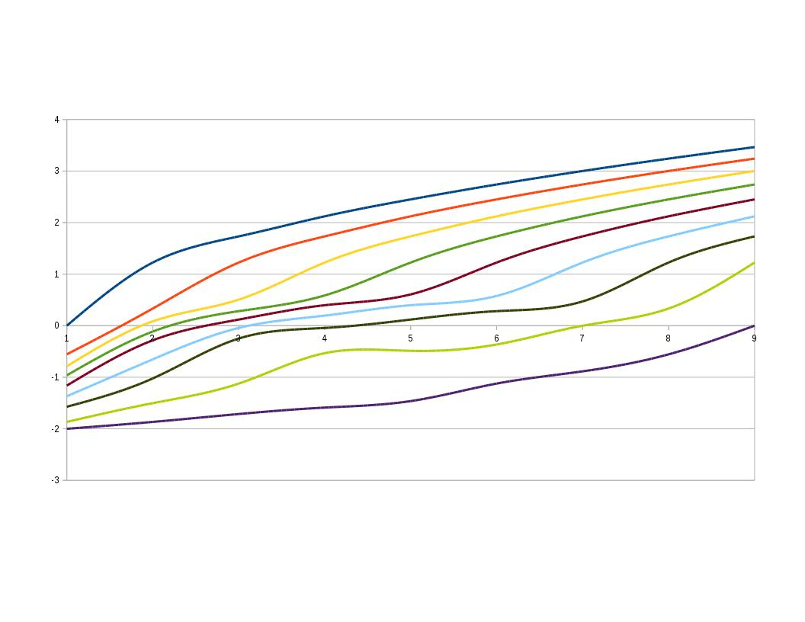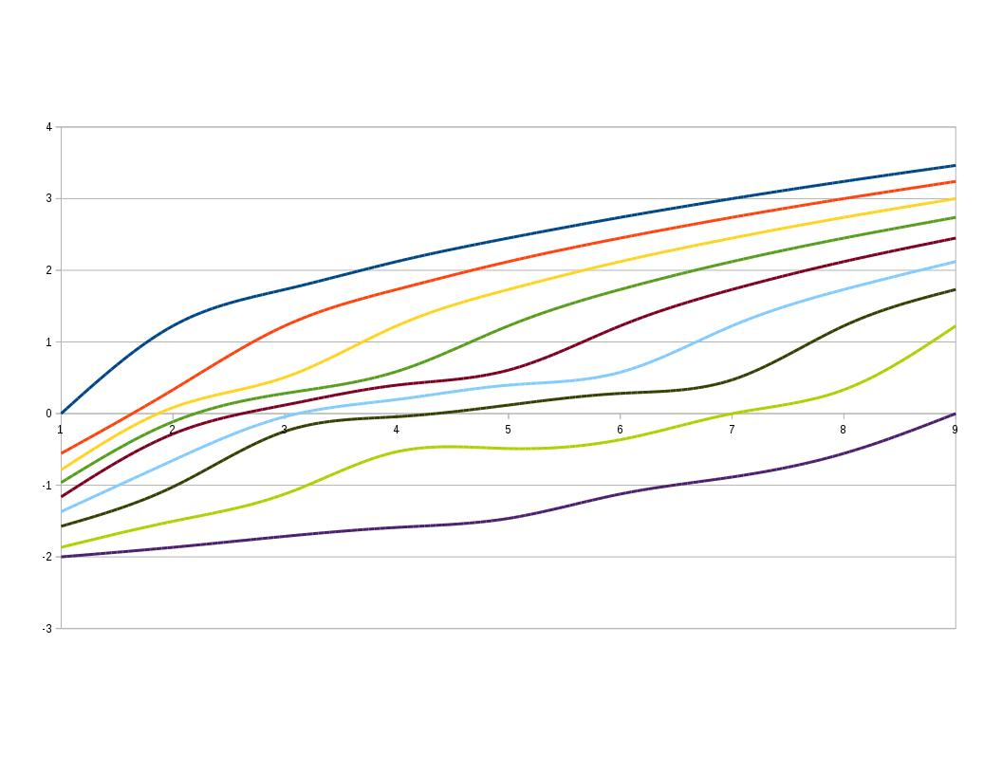

And for 3 stages and 8 nodes, it looks similar to:

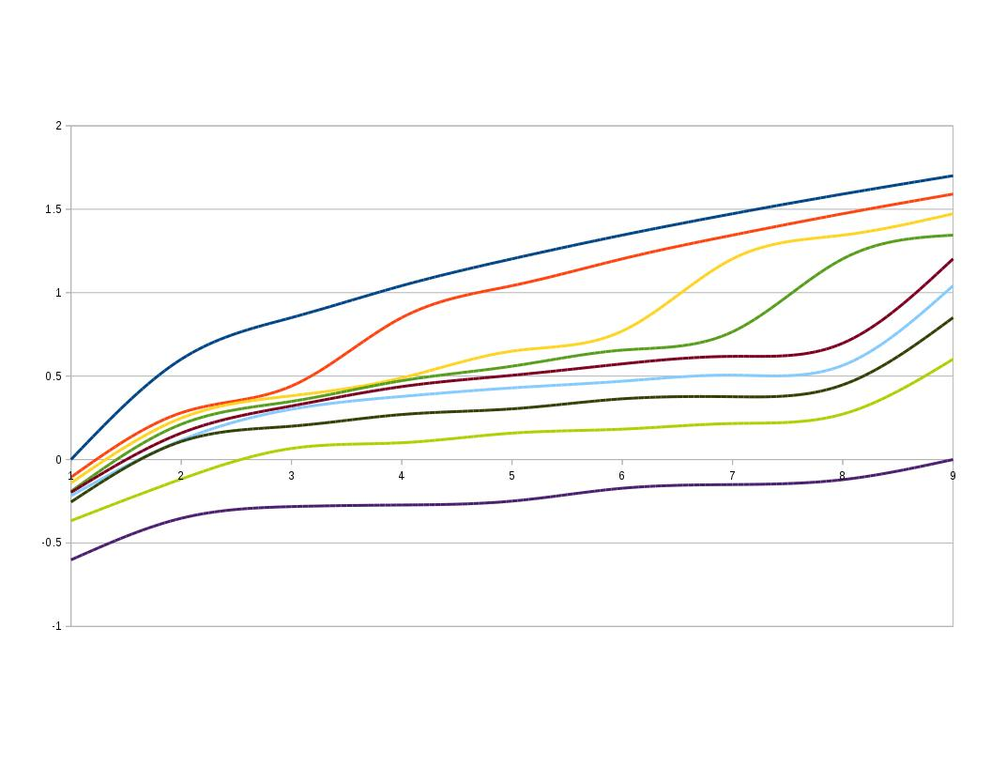

All the plots look similar.

**Technique used for maximum flow evaluation:**

Let’s take the very basic example of 3 stages and 4 nodes. Let’s assume,

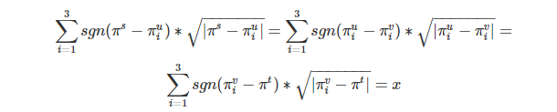

In the equation above, we have 7 variables (inner nodes * 3 + flow value x). Now, our objective is:

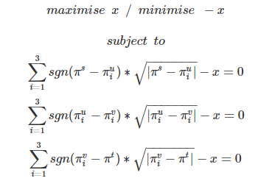

Using python ‘Optimize.minimize’ library, we get easily transform the above problem into a computational algorithm.

The method used for optimisation is ‘SLSQP’. And the python code is as follows:

